Croghan Volunteer Fire Department
PO Box 405
Croghan, NY 13327
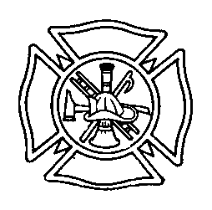

Vehicle Maintenance Committee Best Practice

In order to ensure that all department owned vehicles are in operational condition and ready for a safe response at all times, the department has established a vehicle maintenance committee. This committee reports directly to the Chief. The committee is chaired by a designated assistant chief and consists of qualified members who shall be assigned to individual vehicles.

Monthly Inspections: Each committee member shall complete a monthly inspection on his/her assigned vehicle and fill out the appropriate maintenance log located in the shop area. This inspection shall include (but not limited to) batteries, braking systems, coolant system, electrical system, fuel system, hydraulic fluids, lubricants, oil, tires, steering system, and belts. The vehicle maintenance logs shall be saved and available for review as needed.
The committee member shall correct any minor issues (adding fluids, replacing bulbs etc) and make note of such on the log sheet. Any major issues shall be reported immediately to the chief who shall make a determination of how to proceed. In some cases, the vehicle may be taken out of service until the repairs have been made. In this case, the chief shall notify the membership of such usually either via text message or having an announcement made over pagers).

Annual Inspections: The chief is responsible for any required annual NYS DOT inspection work. In general, this should be scheduled in such a way as to minimize the time the vehicle is out of service.

After Each Call: The driver is responsible for checking vehicles upon returning from a scene and must report any issues with the vehicle to a committee member or chief immediately. The driver, with assistance as needed, is also responsible for making sure all equipment is restored to its proper locations ready for the next call.

Draft 3/2014

