Croghan Volunteer Fire Department
PO Box 405
Croghan, NY 13327
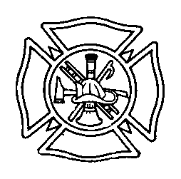

Privately Owned Vehicle (POV) Response Best Practice

When a member responds to the station or to an emergency scene in his/her private vehicle, he/she must strictly adhere to all applicable motor vehicle laws. Privately owned vehicles (POV’s) are not provided with the same exemptions that are provided to emergency vehicles. No member of the Croghan Volunteer Fire Department is permitted to violate any motor vehicle laws, including but not limited to speeding, going through traffic control devices or passing in an unsafe manner.
While it is recognized that timeliness in responding to an emergency is important, it is imperative that all drivers understand that their private vehicles are not emergency vehicles and therefore not afforded any exemptions or special privileges under state law. Any driver observed breaking any traffic laws or operating any vehicle in an aggressive or unsafe manner will be subject to disciplinary action including suspension, loss of driving privileges or withdrawal of courtesy light permit (Blue Card).

Members are encouraged to respond to the fire hall to ensure that all necessary emergency apparatus respond to the scene.

Courtesy Lights- In order to display a courtesy light, a member must have a permission card signed by the current chief. A new card must be issued whenever there is a change in Chief. A blue light is for fire. EMS may use green. Only chiefs will be allowed to use red. These lights must be on the roof of the vehicle or mounted on the dashboard. Again, the courtesy light is just that. It does not give the member any special motor vehicle law exemptions.

Responding to Scene- As with an emergency vehicle responding to a scene, all POVs should be parked on the same side as the scene unless otherwise directed by a member of the Fire Police or Chief. POV’s should be parked a distance from the scene to allow for Emergency Vehicles to park closer to the scene.

Accident Reporting- As with an emergency vehicle, any accident occurring when responding to the scene must be reported immediately to the Chief or at the earliest time a Chief is available( not during an ongoing emergency scene as the Chief has other obligations to attend to at the time.

Draft 3/2014
Reviewed 1/2018

