Croghan Volunteer Fire Department
PO Box 405
Croghan, NY 13327
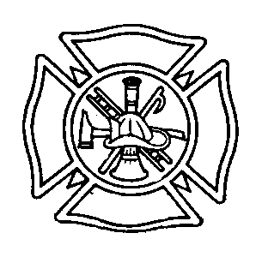
“Proud to Serve”

Outside Contractor Use Best Practice

Upon request from the Executive Board of the Croghan Volunteer Fire Department, individuals or contractors performing services for the department will be required to submit a copy of their Certificate of Insurance to be kept on file.

