Croghan Volunteer Fire Department
PO Box 405
Croghan, NY 13327
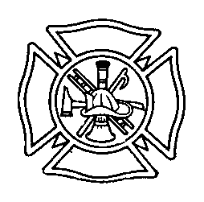

On –Line Training Best Practice

In order to allow members flexibility in meeting the annual 8 hour OSHA training requirement, the Croghan Volunteer Fire Department subscribes to online training courses.

The following guidelines are in place.

No more than 4 hours of online training will count towards the 8 hour annual requirement. (This may be changed with prior approval from the Chief on a case by case basis). The purpose for this is to encourage training with other members of our agency and also to train using our equipment. Likewise, a member is discouraged from using only online training in conjunction with training from other agencies without utilizing direct training with the Croghan Fire Department.

In order to receive credit for the class, the member must pass the quiz.

The following classes are examples of acceptable classes to be used to qualify for OSHA credit. Other classes may also be approved at the discretion of the Chief.

Fire Station Safety and Self Inspection
FireFighter Injury Prevention
Hazardous Communications: MSDS
Functional Fitness for Firefighters
NYS OSHA Introduction to Standards
NYS OSHA Series Assessment
OSHA Personal Protective Equipment
OSHA Standards for the Fire Service
SCBA & Breathing Air Refresher

Adopted 8/1/2013
Revised 2/2014 Chief Keith Bush
Reviewed 1/2018

