Croghan Volunteer Fire Department
PO Box 405
Croghan, NY 13327
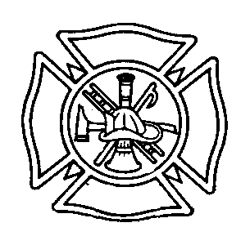

USE OF THE INCIDENT COMMAND SYSTEM BEST PRACTICE

Purpose: To ensure the safety of all members of the Croghan Fire Department the Incident Command System (ICS) shall be used at all emergency situations.

Procedure: At all emergency situations responding members of the Croghan Fire Department will be under the direction of the highest-ranking officer on scene. The order of command shall be as follows:

Chief
Chief 1
Chief 2
Chief 3

(Note: In absence of a Chief the pump operator shall be the Incident Commander until relieved by a Chief)

On large-scale incidents the officer in charge shall establish command and assign duties as needed to control the incident. In order to make proper decisions all personnel assigned tasks must communicate with Command to make sure information and resources are used accordingly.

Revised 1/2014 1/2018

