Croghan Volunteer Fire Department
PO Box 405
Croghan, NY 13327
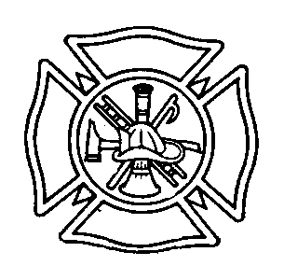
Fire Police Best Practices

1/ Be prepared to respond to emergency calls promptly but safely.

2/ Attendance at meetings and drills is expected.

3/ Anticipate that the fire police may be among the first to arrive at a scene and the last to leave.

4/ Each member of the fire police squad is responsible to keep their equipment properly cared for and ready for service.

5/ The first member of the fire police in the area should direct traffic on Main St.in front of Firehall St. to assure emergency vehicles a safe and expedient response.

6/ Follow instructions of the fire police chief and/or fire chief while in route via radio if possible.

7/ If no officer is present at the scene upon arrival, evaluate the situation at hand and relay the information to responding units. Be aware of anything that may assist the investigation later.

8/ Evaluate the traffic and natural hazards that you see and anticipate problems that are likely to arise.

9/ Keep the roads open for emergency traffic at all times.

10/ Locate other members of the fire police as soon as possible to assist in controlling traffic and bystanders at the scene.

11/ Direct emergency vehicles and firemen to follow correct parking procedures, while maintaining traffic flow as the situation warrants. Roads may be temporarily closed, however should be reopened as soon as possible.

12/ Determine a safe distance perimeter as off-limits to non-emergency personnel.

13/ Keep in contact and work closely with other fire police and law enforcement.

14/ When not in direct contact with other members of the squad, use hand, sign and/ or flag signals.

15/ Be firm and decisive, but courteous at all times when giving directions or
assistance to the public.

16/ Do not give out pertinent information regarding the emergency situation
to non-emergency personnel.

17/ Do not leave assigned posts until directed by the fire police chief or the officer in charge or until all activity has ceased at that location.

18/ Following any emergency or training, meet with other fire police to critique the performance of the fire police. Questions to be reviewed include: Did the fire police accomplish the goal of insuring the safety of the department and the general public? Did the fire police perform professionally, efficiently and courteously in the eyes of the public.

Effective 04/15/2010
Reviewed 2/2015 1/2018

