Croghan Volunteer Fire Department
PO Box 405
Croghan, NY 13327
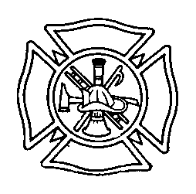

Active Member Best Practices

All active members of the Croghan Volunteer Fire Department are expected to meet the following Annual Requirements.

- Respond to a minimum of 10% of Emergency Calls.
- Complete a minimum of 8 hours of OSHA approved department training. See separate policy on specific training guidelines.
- Attend a minimum of 5 meetings
- Actively serve as an officer or serve on one committee. In the case of committee work, the committee chairperson is responsible for ensuring that all members participate in order to earn credit.

Beginning in January, designated members of the Executive Board will be responsible for determining which members have met the category requirements by consulting with various officers ( secretary, Chief etc).

The Executive Board shall determine an awards system for members who meet the requirements.

Members not meeting training requirements will be sent a letter notifying them that they are unable to participate on emergency calls until the training is current.

No disciplinary action will be taken against members deficient in other categories.

In the case of a member who is consistently deficient in more than one category, they may be requested to meet with the Executive Board in order to discuss their level of interest in being a member of the Croghan Fire Department at the current time.

Generally speaking, in order to run for an elected office, the member must have met all requirements as an active member during the prior year. The Executive Board has the authority to waive this requirement on a case by case basis.

Revised 1/2016

