Croghan Volunteer Fire Department
PO Box 405
Croghan, NY 13327
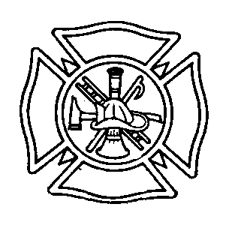
ACCOUNTABILITY BEST PRACTICE

Purpose: To ensure that all members whereabouts and safety on scene at any emergency the Croghan Fire Department will do on scene accountability.

Procedure: Accountability will be done on two levels. Level 1 is accountability for all responders. Level 2 is for personnel doing interior firefighting duties. If any firefighter is reported missing, lost, or injured, the accountability system can identify who is missing. All members must take responsibility for the effectiveness of this system and will be responsible to tag themselves in and out of service.

Level 1

Level one accountability takes into consideration that all members that respond to an emergency scene are to be accounted for. When a firefighter arrives on the scene of an emergency, whether by riding in a department piece of apparatus or by their own personal vehicle, they must make known to the Chief In Charge (CIC) and the Safety Officer that they are on scene by clipping their department issued identification tag to front of Rescue 1. This identification tag will let the CIC and the Safety Officer know that the member is in service at the scene. When a member leaves the scene they will remove the identification tag only after they have told the CIC that they are leaving the scene or have been relieved from duty by the CIC. At the end of all incidents the CIC will check to see if any tags are still clipped to Rescue 1. If any tags remain the CIC will not terminate command until that member is accounted for.

Level 2

Level two accountability is for interior firefighters. Before entering any structure, all interior firefighting personnel will give the Safety Officer his or her tag from their pass device. The Safety Officer will then fasten the tags to his accountability board and will make note of the team they are joining as well as the time and assignment. Upon leaving the structure, the firefighter will return to the Safety Officer first to retrieve their tag and the Safety Officer will either stage the firefighter for their next assignment or send the firefighter to rehab for a rest period.

Effective: 11/6/2008 By: Chief Joseph E. Aucter
Revised: 2/4/2010
Reviewed: 1/2014

