Croghan Volunteer Fire Department
PO Box 405
Croghan, NY 13327
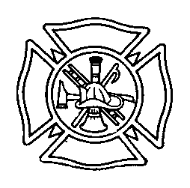

Service Award Recognition Best Practice

In order to maintain consistency in recognizing the years of service for members of the Croghan Volunteer Fire Department, the following guidelines have been established.

Awards for Years of Service with the Croghan Volunteer Fire Department will be recognized as follows:

- All increments of 5 years of service will receive a certificate of appreciation.

- All increments of 5 years of service will have the opportunity for photo recognition to include Journal and Republican

- All increments of 5 years of service starting with 20 years and thereafter will receive a monetary gift card.

- All Major years of service MAY be eligible for official Recognition with the NYS Office of Fire Prevention and Control. It is the responsibility of the Midwinter Banquet Committee to work with the Department President to contact this office.

Drafted 2/2016

