Croghan Volunteer Fire Department
PO Box 405
Croghan, NY 13327
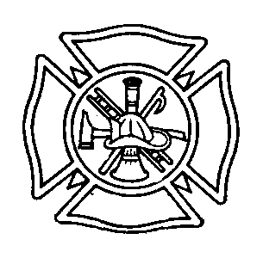
Fire Chief(s) and Fire Police Captain Qualification Best Practice

Purpose: To ensure that members of the Croghan Vol. Fire Department are qualified to assume command and make the proper decisions at any event or emergency situation.

Procedure: To be eligible to be elected Chief, Assistant Chief, or Fire Police Chief the following qualifications are recommended. Exceptions can be made by the Executive Board.

Fire Chief(s) Recommended Criteria
1) Fire Officer 1
3) Pump Operator Certification
4) EVOC Certification
5) Fire Behavior and Arson Awareness Course
6) Valid NYS driver License
7) Hazmat Operations or higher Certification
8) Be an active member minimum of 3 consecutive years prior
9) ICS 100, 200 and 700

Extended Criteria for Chief
1) Be an Assistant Chief within 5 yrs prior
2) If past Chief is out for more than five years they should re-enter as an Assistant Chief
Fire Police Captain Recommended Criteria
1) Must have Fire Police School
2) ICS 100, 200 and 700
3) Valid NYS driver License
4) EVOC Certification
6) Be an active member minimum of 3 consecutive years prior

Effective: 11/6/08 By: Executive Board
Revised: 1/2016

