Croghan Volunteer Fire Department
PO Box 405
Croghan, NY 13327
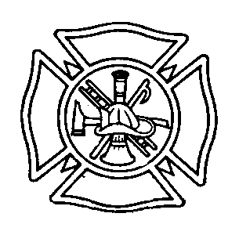

RADIO PROTOCOL BEST PRACTICE

Purpose: To have all communication standardized to ensure that the ICS system functions properly.

Procedure: In the event of being dispatched to an emergency the following radio procedures will be done every time:

When dispatched to a fire only one Chief will call en-route and on scene. Only first fire apparatus out will call en-route and on scene. After the first fire unit calls en-route all responding units will go to channel 2. Any deviation from this the order must come from a Chief.

In the event that other channels are needed to be used this order will come from command. The Croghan Fire Department will utilize the following channels for the operation listed:

Channel 1 – Communication with Lewis Dispatch
Channel 2 – Truck to truck / ground operations
Channel 3 – Interior Firefighting / Pump Relay
Channel 4 – Jefferson County Fire Control
Channel 5 – Fire Police

When communicating with Lewis Dispatch the following will identify the all vehicles:

Croghan Engine 1 (Custom)
Croghan Engine 2 (FMC)
Croghan Tanker 1
Croghan Rescue 1 (F-550)
Croghan Rescue 2 (F-350)
Croghan Rescue 3 (UTV)

Effective: 11/6/2008 By: Chief Joseph E. Aucter

Revised 1/2016

