Croghan Volunteer Fire Department
PO Box 405
Croghan, NY 13327
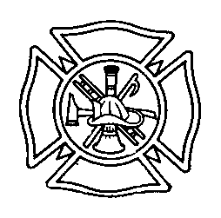
Highway Scene Safety Best Practice
Background: Fire or EMS emergencies occurring on or near a highway present additional safety concerns for responders. The Croghan Volunteer Fire Department shall incorporate the following practices in order to protect the safety of victims and Fire/EMS/Law Enforcement personnel. These guidelines shall exist with other department policies such as “Responding to an Emergency Scene” and “Fire Police Duties”. In general, the basic rule of thumb for members is to never trust approaching traffic and avoid turning your back on approaching traffic.
Procedures:
An initial block should be established with the first arriving emergency vehicle or fire apparatus. This “block” should create a sufficient size work zone that includes all damaged vehicles, roadway debris, the patient triage and treatment area, the extrication work area, personnel and tool staging area and the ambulance loading zone.
All fire department members shall wear class II high visibility vests or OSHA approved turnout gear with high visibility markings at all times when operating on or near a highway. It shall be the duty of the chiefs and/or safety officer to enforce this.
The incident commander will make a determination on whether or not to shut down the roadway completely or to allow limited traffic flow. In either case, the chief should relay this information to the fire police as soon as possible to take appropriate action. If the roadway is to be shutdown, the chief must relay this information to Lewis County Dispatch.
Fire Police Placement: Fire police personnel need to position themselves on either side of the scene at a safe distance away from the incident. If additional fire police personnel are available, they may position themselves directly at the scene to help direct the flow of traffic including responding units.The fire police may utilize traffic cones, emergencies signs or flares as determined necessary to assist with the flow or redirection of traffic.
Other: Turn off all sources of vision impairment to approaching motorists at nighttime incidents including vehicle headlights and spotlights.Command shall stage unneeded emergency vehicles off the roadway or return these units to service whenever possible.
Reviewed 2/2015 1/2018

