Croghan Volunteer Fire Department
PO Box 405
Croghan, NY 13327
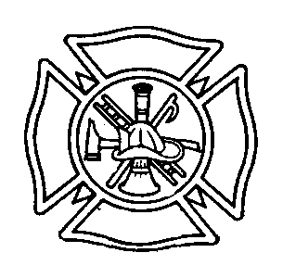
DRIVER TRAINING BEST PRACTICE

Purpose: To ensure that all members are properly trained in safe driving practices of department owned vehicles.

Procedure: The Croghan Fire Department will use a driver list to show which members are qualified to drive department owned vehicles. List below are the steps that need to be taken to be put on the list and also remain on the driver list.

Must have a valid New York State driver license, class D or higher with no conditions.
Must undergo department review of DMV driver license record prior to being eligible for drivers list ( at no expense to member).
Must have OFPC recognized Emergency Vehicle Operator Course (EVOC).
Must have mandatory number of hours logged on driver training sheet as driver training (See list of mandatory hours below).
Training Times
Tanker – 5 hours
Engine 1 Engine 2 – 4 hours (can be 2 hours on each)
Rescue 1/Rescue 2 - 2 hours (can be divided among vehicles to include ½ hour on ambulance multiplex system)

- Will need to be given a check out test by a department-approved observer before being put on the driving list.

- Driver must be familiar with all operations of the apparatus, should know the location of the equipment located on the truck and be trained to operate the truck. (I.E. Pump operator must have pump operator school.)

- Drivers will be added to the list when they have met these requirements. The list will be updated as needed. The Chief will have the final say as to who is on the driver list.

- Must have two hours of drive time annually to remain on the drivers list.

SUPPORT VEHICLE
** In addition to fire apparatus, the department also has a UTV( Rescue 3) and a Rescue Boat. Regular training with these support vehicles will be incorporated into the department’s annual training opportunities. A trained member familiar with the operation of this equipment will be operating or supervising the operation of these support vehicles at all times.

Effective: 11/6/2008 By: Chief Joseph E. Aucter
Revised: 1/2016

