Croghan Volunteer Fire Department
PO Box 405
Croghan, NY 13327
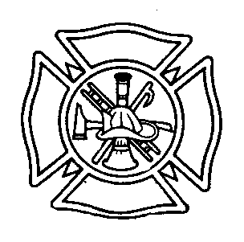
“Proud to Serve”

VEHICLE ACCIDENT REVIEW BEST PRACTICE

I SCOPE
This standard establishes the Croghan Volunteer Fire Department Vehicle Accident Review Best Practice which requires that a systematic review of every accident involving a motorized vehicle be conducted with recommendations for corrective actions to prevent further accidents and recommendations for disciplinary actions to be taken as deemed appropriate.

II PROCEDURE

      - Every vehicle accident shall be reviewed using the guidelines listed below. This review will be conducted by department officers which MAY include chief(s), safety officer and members of the executive board. (The President and Chief will determine who needs to be involved on a case by basis). A written report detailing the background of the accident, and recommended actions shall be completed.

      - A copy of the board’s report shall be provided to each member involved in the accident, and a copy of the report shall be placed in the member’s permanent personnel file.

      - Disciplinary action shall be administrated as provided in the appropriate section of the department’s rules, regulations, and procedures.

IV GUIDELINES

  - All accidents shall fall into one of theses categories:
    - Category One: Nonpreventable.
    - Category Two: Driver part at fault.
    - Category Three: Driver totally at fault.

  - Category One accidents are those accidents in which no action could have been taken by the driver to prevent the accident. This shall require that an appropriate written report be filled and no disciplinary action be taken.

  - Category Two accidents are those accidents in which the driver is judged to have been partially at fault and could have been prevented the accident. Disciplinary action may be recommended to the authority having jurisdiction.

  - Category Three accidents are those accidents in which the driver was totally at fault. Disciplinary action shall be in direct proportion to the seriousness of the accident and shall range from a written reprimand to an indefinite suspension.
Examples:
    - A written reprimand should be sufficient for a first offense when the damage was less than $1,000.00 and there were no deaths or bodily injuries.

    - An indefinite suspension should be recommended when one or more of the following conditions were present:

      - The driver had multiple offenses during the previous 24 months.

      - There was bodily injury or death.

      - The driver was intoxicated or otherwise impaired.

Adopted 1/2014

