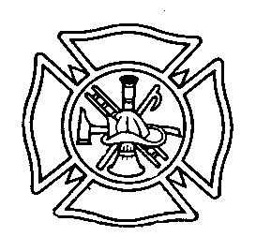
“Proud To Serve”
Croghan Volunteer Fire Department
p.o. box 405
Fire Hall Street
Croghan, N.Y. 13327

Date ____________ President _____________________ Chief ______________________

CORRECTIVE DISCIPLINE SOP

It shall become the policy of the Croghan Vol. Fire Dept. to maintain and utilize the following Corrective Discipline Policy. The purpose of this policy is to ensure that all situations are documented and that the member is treated fairly. The Executive Board of the Croghan Fire Dept. will be responsible for this policy as stated in the department By-laws. All actions will be taken in steps as listed below. If no further action is taken in 90 days then the Corrective Discipline Sheet will be removed from the membership file, unless otherwise stated by the Executive Board. The Executive Board reserves the right depending on what occurred to start at the appropriate step.

Step 1

Verbal Counseling – The Chief or Executive board will verbally talk to Member. This will be written down for documentation reasons on the corrective discipline form. If the Chief does this he will make the Executive Board aware at their next meeting.

Step 2

Written Warning / Probation – Member will be informed in writing of the incident that occurred. (This will be done by the Executive board.) (Member must be present)

Step 3

Suspension – Member will be suspended after a hearing held by the Executive board. Length of suspension is to be determined by the Executive Board. (Member must be present)

Step 4

Expulsion Vote – Formal Charges will be filed against member and a two-thirds majority vote will be taken as stated in By-laws. (Member must be present)

